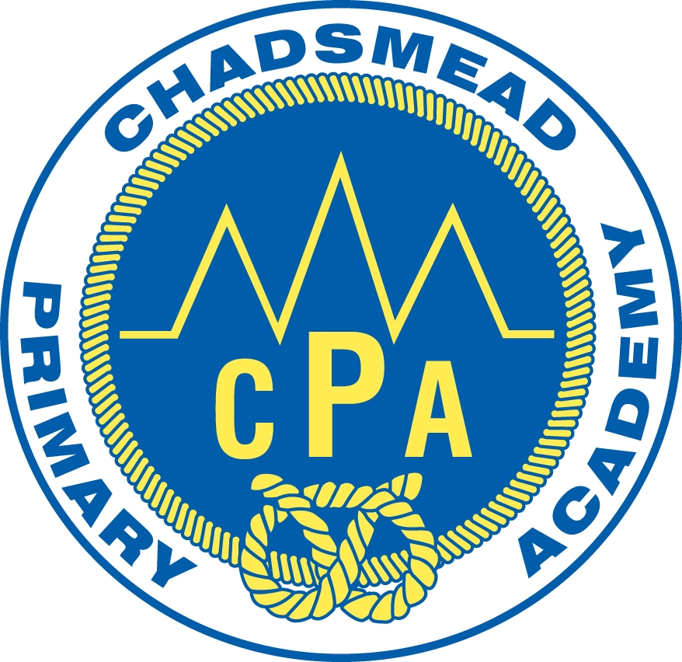

Chadsmead Primary Academy

Admissions Policy

ADMISSIONS TO SCHOOL

NEW INTAKE AND
IN-YEAR TRANSFERS
2017/2018

Contents
Chadsmead Primary Academy Nursery Setting 1
Oversubscription Criteria 1
How to apply 2
Additional Notes 3
Chadsmead Primary Academy 5
Oversubscription Criteria 5
Additional Notes 6
Deferred Entry to Reception Class 7
Admission Outside of the Normal Age Group 8
Waiting Lists 8
Appeals against Determined Admission Arrangements 8
Late Applications 9
Published Admission Numbers and School Place Capacity at 9
Chadsmead Primary Academy 9
“In-Year Transfer” Arrangements 9
Acceptance of School Place 10
Timetable for Admissions 2016/17 10

Adapted from a Staffordshire County Council document

Admission Arrangements for

Chadsmead Primary Academy Nursery

Chadsmead Primary Academy Nursery Setting
Children can be admitted in the term after they become 3 years old. We run a cycle of 3 term admissions; September, January and April. Children are admitted into Group A or Group B. There are 52 places available overall in both groups, for the 3 points of entry.
Group A runs all day Monday and Tuesday and Wednesday morning to fulfil the requirement of 15 hours provision.
Group B runs Wednesday afternoon and all day Thursday and Friday to fulfil the requirement of 15 hours provision.
It is also possible for parents to subscribe to our Little Chads setting, which runs on Wednesday afternoon, and all day Thursday and Fridays. This service offers a low cost child care option for working parents. Little Chads is only available for children on roll at our Nursery in Group A.
It is Chadsmead Primary Academy’s policy to try and meet parents’ wishes where possible, however in some cases there may be more applications for a particular intake than there are places. Admission to Nursery will be determined by the oversubscription criteria detailed below.

Oversubscription Criteria
If the total number of applications for admission to Chadsmead Primary Academy Nursery setting exceeds the number of available places, then the following order of priority will be used to allocate the available places.

1) Relevant Children in Care, including those previously determined as Looked After Children. (That is, children who were looked after but ceased to be so because they were adopted (or became subject to a residence order or special guardianship order).

2) Children living within the defined catchment or cluster area of the Academy. Cluster areas for nursery will correspond to the catchment area for the main school.

3) Children who have an elder brother or sister in attendance at the Academy and who will still be attending the school at the time of the proposed admission date. (For admission purposes, a brother or sister is a child who lives at the main address provided and either: have one or both natural parents in common; are related by a parents marriage; are adopted or fostered by a common parent or are unrelated children who live at the main address, whose parents live as partners.)

4) Children who satisfy both of the following tests:

Test 1: The child is distinguished from the great majority of other applicants either on their own individual medical grounds or by other exceptional circumstances.

Medical grounds must be supported by a medical report (obtained by the applicant and provided at the point of application). This report must clearly justify, for health reasons only, why it is better for the child’s health to attend Chadsmead Primary Academy Nursery rather than any other nursery.

Exceptional circumstances must relate to the choice of nursery and the individual child, i.e. the circumstances of the child, not the specific economic or social circumstances of the parent/carer, and be supported by a professional report (obtained by the applicant and provided at the point of application), e.g. social worker, justifying why it is better for the child to attend Chadsmead Primary Academy Nursery rather than any other nursery.

and

Test 2: the child would suffer hardship if they were unable to attend the Chadsmead Primary Academy Nursery.

Hardship means severe suffering of any kind, not merely difficulty or inconvenience, which is likely to be experienced as a result of the child attending a different school. Applicants must provide detailed information about both the type and severity of any likely hardship at the time of application.

5) Other children will be arranged in order of priority, according to how near their home addresses are to the main gate of Chadsmead Primary Academy Nursery, determined by Google Walking Route Map.

Where it is not possible to accommodate all children applying for places within a particular category then Chadsmead Primary Academy will allocate the available places in accordance with the remaining criteria. If for instance, all the catchment or cluster area children cannot be accommodated at a school, children who are catchment or cluster area children and satisfy category (3) will receive offers of a place, followed by children who live in the cluster area and satisfy category (4), etc.

How to apply –The closing for nursery applications will generally be the Friday before every half term, for a start date of the following term. For 2017/18 the closing dates are:

Friday 26 May 2017 (for September 2017 start)
Friday 21 October 2017 (for January 2018 start)
Friday 17 February 2018 (for April 2018 start)

Parents will be notified of the outcome 4 weeks after the closing date.

Additional Notes

Copies of school catchment area maps are available on request.

There is no charge or cost related to the admission of a child to a school.

Attendance at Chadsmead Primary Academy Nursery will not guarantee admission to any particular Reception Class or give any advantage to the child’s application for Reception. Parents must reapply for admission to Reception at the appropriate time.

In accordance with legislation, children who have a statutory statement of special educational need or Education, Health and Care Plan that names Chadsmead Primary Academy Nursery will be admitted to our Nursery setting. This may reduce the amount of places available to other applicants.

Relevant Children in Care means children who are in the care of a local authority in accordance with section 22 of the Children Act 1989(b) and who (a) are looked after at the time an application is made and (b) in relation to whom the local authority has confirmed that the children will still be looked after at the time when the child will be admitted to school. It has also recently been extended to include those previously determined as Looked After Children. (That is, children who were looked after but ceased to be so because they were adopted (or became subject to a residence order or special guardianship order).

It is the applicant’s responsibility to provide any supportive information required in order for the application to be assessed against the published admissions criteria, Chadsmead Primary Academy will not seek to obtain this information on behalf of the applicant.

The home address is considered to be the child’s along with their parent/carer’s main and genuine principal place of residence at the time of the allocation of places i.e. where they are normally and regularly living. If a child is resident with friends or relatives (for reasons other than legal guardianship) the friends or relative’s address will not be considered for allocation purposes.

Where parents have shared responsibility for a child, and the child lives with both parents for part of the school week, parents will be required to provide documentary evidence to support the address they wish to be considered for allocation purposes.

If there are a limited number of spaces available and we cannot distinguish between applicants using the criteria listed, such as in the case of children who live in the same block of flats or are the result of a multiple birth, then the child or children who will be offered the available spaces will be randomly selected by drawing lots.

Unsuccessful applicants will be placed on a waiting list in accordance with the oversubscription criteria stated above. If places become available after the offer date they will be offered to the child at the top of the waiting list. Waiting Lists will be kept until the end of the autumn term of admission. Children will remain on the waiting until the end of Summer 1 Term Half term (May Half Term) of the year in which they turn four unless a place is declined by the parent/carer.

Inclusion on a school’s waiting list does not mean that a place will eventually become available at the preferred school. A child’s position on a waiting list is not fixed and is subject to change during the year, i.e. they can go up or down the list.

There is no statutory right of appeal for admission to a nursery setting. Any disputes over the administration of the policy will be dealt with by the Governor’s complaints procedure.

Admission Arrangements for

Chadsmead Primary Academy

Chadsmead Primary Academy
Full-time places in Reception become available in September of the academic year in which a child becomes five years old. Chadsmead’s PAN is 60 for the main school and 52 in Nursery.

At that point, although parents have the right to express a preference for a particular school for their child, there is no guarantee of a place being offered at their preferred school.

Where possible Chadsmead Primary Academy would aim to meet parents’ wishes, however, where demand exceeds available places certain statutory criteria must be adhered to when making an allocation of Reception places.

Oversubscription Criteria
Where the requests for admission exceeds Chadsmead Primary Academy’s Published Admission Number (PAN) and the available places within the school structure (see additional notes), the following order of priority will be used to allocate places:

1) Relevant Children in Care, including those previously determined as Looked After Children. (That is, children who were looked after but ceased to be so because they were adopted (or became subject to a residence order or special guardianship order).

2) Children living within the defined catchment or cluster area of the Academy. Cluster areas for nursery will correspond to the catchment area for the main school.

3) Children who have an elder brother or sister in attendance at the Academy and who will still be attending the school at the time of the proposed admission date. (For admission purposes, a brother or sister is a child who lives at the main address provided and either: have one or both natural parents in common; are related by a parents marriage; are adopted or fostered by a common parent or are unrelated children who live at the main address, whose parents live as partners.)

4) Children who satisfy both of the following tests:

Test 1: The child is distinguished from the great majority of other applicants either on their own individual medical grounds or by other exceptional circumstances.

Medical grounds must be supported by a medical report (obtained by the applicant and provided at the point of application). This report must clearly justify, for health reasons only, why it is better for the child’s health to attend Chadsmead Primary Academy rather than any other school.

Exceptional circumstances must relate to the choice of school and the individual child, i.e. the circumstances of the child, not the specific economic or social circumstances of the parent/carer, and be supported by a professional report (obtained by the applicant and provided at the point of application), e.g. social worker, justifying why it is better for the child to attend Chadsmead Primary Academy rather than any other school.

and

Test 2: the child would suffer hardship if they were unable to attend the Chadsmead Primary Academy.

Hardship means severe suffering of any kind, not merely difficulty or inconvenience, which is likely to be experienced as a result of the child attending a different school. Applicants must provide detailed information about both the type and severity of any likely hardship at the time of application.

5) Other children will be arranged in order of priority, according to how near their home addresses are to the main gate of Chadsmead Primary Academy, Other children will be arranged in order of priority, according to how near their home addresses are to the main gate of Chadsmead Primary Academy, determined by Google Walking Route Map.

Where it is not possible to accommodate all children applying for places within a particular category then the Local Authority will allocate the available places in accordance with the remaining criteria. If for instance, all the catchment or cluster area children cannot be accommodated at a school, children who are catchment or cluster area children and satisfy category (3) will receive offers of a place, followed by children who live in the cluster area and satisfy category (4), etc.

Additional Notes
Copies of school catchment area maps are available on request.

There is no charge or cost related to the admission of a child to a school.

In accordance with legislation, children who have a statutory statement of special educational need or Education, Health and Care Plan that names Chadsmead Primary Academy will be admitted to our school setting. This may reduce the amount of places available to other applicants.

Relevant Children in Care means children who are in the care of a local authority in accordance with section 22 of the Children Act 1989(b) and who (a) are looked after at the time an application is made and (b) in relation to whom the local authority has confirmed that the children will still be looked after at the time when the child will be admitted to school. It has also recently been extended to include those previously determined as Looked After Children. (That is, children who were looked after but ceased to be so because they were adopted (or became subject to a residence order or special guardianship order).

It is the applicant’s responsibility to provide any supportive information required in order for the application to be assessed against the published admissions criteria, Chadsmead Primary Academy will not seek to obtain this information on behalf of the applicant.

The home address is considered to be the child’s along with their parent/carer’s main and genuine principal place of residence at the time of the allocation of places i.e. where they are normally and regularly living. If a child is resident with friends or relatives (for reasons other than legal guardianship) the friends or relative’s address will not be considered for allocation purposes.

Where parents have shared responsibility for a child, and the child lives with both parents for part of the school week, parents will be required to provide documentary evidence to support the address they wish to be considered for allocation purposes.

The requirement for Chadsmead Primary Academy to meet the nationally determined Infant Class Size legislation, may result in the refusal of catchment area or sibling applications, where a class has already reached its limit of 30 pupils. However, where meeting the requirements of infant class size legislation will result in the separation of twins or siblings from multiple births Chadsmead Primary Academy will give careful consideration to exceeding the published admission number. The same consideration will be applied to returning UK Service Personnel families, who may be admitted outside the normal admission round.

If there are a limited number of spaces available and we cannot distinguish between applicants using the criteria listed, then the child or children who will be offered the available spaces will be randomly selected by drawing lots.

Deferred Entry to Reception Class
Parents may request that their child be admitted to Reception Class on a part-time basis, or that their child be admitted to school later in the same academic year until the child reaches compulsory school age (i.e. beginning of the term after the child’s fifth birthday). The effect is that the place will be held for the child in Reception and is not available to be offered to any other child within the same academic year in which it has been offered.

Before deciding whether to defer their child’s entry to school, parents should visit their preferred school(s) to clarify how they cater for the youngest children in Reception and how the needs of these children are met as they move up through the school.

Admission Outside of the Normal Age Group
Parents may seek to apply for their child’s admission to school outside of their normal age group, for example if the child is exceptionally gifted and talented or has experienced problems such as ill health. In addition, the parents of summer born children may choose not to send their child to school until the September following their fifth birthday and may request that they are admitted outside of their normal age group to Reception rather than Year 1.
These parents will need to make an application alongside children applying at the normal age which should explain why it is in the child’s best interest to be admitted outside of their normal age which may include information such as professional evidence as to why this is the case and why an exception should be made in the case of the child. A decision as to whether this is an appropriate course of action will be made by the Local Authority who will take into account the circumstances of the case and views of the Headteacher of the community or voluntary controlled school concerned. Parents do not have the right to insist that their child is admitted to a particular year group.

Waiting Lists
Unsuccessful applicants will be placed on a waiting list in accordance with the oversubscription criteria stated above. If places become available after the offer date they will be offered according to the child at the top of the waiting list.

Waiting Lists will be kept until the end of the autumn term of admission. No other waiting lists will be maintained. Inclusion on Chadsmead Primary Academy’s waiting list does not mean that a place will eventually become available.

A child’s position on the waiting list is not fixed and is subject to change during the year i.e. they can go up or down the list. Children who are subject of a direction by a local authority to admit or who are allocated to Chadsmead Primary Academy, in accordance with the Fair Access Protocol (further information on this Protocol available on request), will take precedence over those on the waiting list.

Appeals against Allocation of Places
In the event of a dispute regarding allocation of places, parents will have the right to lodge an appeal with an Independent Appeals Panel. A revised School Admission Appeals Code came into effect on 1 February 2012.

Appeals against Determined Admission Arrangements
The new Code introduces a different route for lodging objections to the determined admissions arrangements of Academies. Previously these were submitted to the YPLA. From now on they should be submitted to the Office of the Schools Adjudicator (OSA). This change applies only to formal objections about determined admissions arrangements.
The Code requires Academies to have in place procedures which are slightly different to those of maintained schools. The Appeals Procedure must contain the following three stages, for any objection with regards the Admissions Policy:
- An opportunity to resolve the complaint with the Academy on an informal basis.
- A formal complaint made in writing.
- An opportunity for unresolved complaints to be heard by a panel of governors not directly involved in the matters detailed in the complaint and including a member independent of the management and running of the school.

Late Applications
Application forms received after the closing date will be considered alongside those applicants who applied on time wherever possible. Where it is not practicable because places have already been allocated, or are shortly to be allocated, then late applicants will be considered only after those applicants who applied by the published closing date.

A late application does not affect the right of appeal or the right to be placed on Chadsmead Primary Academy’s waiting list.

Published Admission Numbers and School Place Capacity at

Chadsmead Primary Academy
A school’s Published Admission Number (PAN) reflects the maximum number of children to be admitted at the normal age of entry and should only be exceeded in exceptional circumstances and with prior agreement from the Local Admissions Forum. Published Admission Numbers for all local schools are available from Staffordshire County Council School Admissions website. Chadsmead Primary Academy PAN is 60 for Reception to Year Six. Nursery is 26 in each Group.

In addition to the Published Admission Number which is published it should be recognised that in some academic years Chadsmead Primary Academy operates a school structure with amalgamated year groups. This may result in larger year cohorts and may give practical limitations to the number of school places able to be offered at any given time. This is of particular relevance when requests are received from parents or carers for an In-Year Transfer from another school.

“In-Year Transfer” Arrangements
Parents or carers seeking to transfer to Chadsmead Primary Academy must make an application using the appropriate application form, available from current school within Staffordshire. Requests for admission from outside of Staffordshire will be dealt with by telephone or in writing. Any application will be duly processed in the normal way but parents and carers need to be aware that any date set for joining the Chadsmead Primary Academy may be after the next term or half term holiday and those parents/carers are responsible for ensuring that their child continues to receive appropriate education in the interim. Where possible Chadsmead Primary Academy will seek to fulfil requests as soon as is practicable.

Acceptance of School Place
Parents will have at least two weeks after the date of offer to notify Chadsmead
Primary Academy as to whether or not he/she wishes to accept the place offered.

Timetable for Admission 2017/2018

Action | Dates
All applications for Secondary School to be submitted to School Admissions and Transport Service (Chadsmead Primary Academy to assist by informing parents) | 31 October 2017
RECEPTION - CLOSING DATE - Applications for Reception places to be submitted to School Admissions and Transport Service | 15 January 2017
RECEPTION – OFFER DAY | 18 April 2017
NURSERY - CLOSING DATES – Applications for Nursery places to be submitted to the school. | Friday 26 May 2017 (for September 2017 start)  Friday 21 October 2017 (for January 2018 start)  Friday 17 February 2018 (for April 2018 start)
NURSERY - Parents notified of outcome | 4 weeks after the relevant closing date

