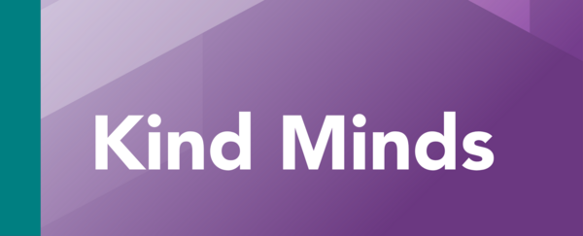

Issue 24: Summer 2025

Welcome to the summer edition of Kind Minds.
Staffordshire partner newsletter with useful information about children and young people’s mental health and emotional wellbeing.
In this issue:
- New emotional wellbeing and mental health service launches
- Update from Mental Health Leads network
- Recommended apps to support mental health
- How to make a referral for support
- New sensory needs toolkit for schools
- Staffordshire Children's Rights Service
- Resources
- Dates for your diary
- Free suicide prevention training and resources
- Training
- Evidence library
- Helplines

New 'Stay Well' service will support hundreds of Staffordshire children and young people
On 1 April 2025, a new service opened to provide emotional health and wellbeing support for children and young people aged five to 18 years old (25 years with SEND) in Staffordshire.
The service, called Stay Well, will also help families and professionals gain the knowledge and confidence to create an emotionally healthy environment and support children and young people.
Stay Well offers early intervention and prevention through:
- Group and one-to-one emotional health and wellbeing sessions for children and young people
- Peer support groups for children and young people
- Access to a wide range of positive activities for children and young people
- Information, advice and guidance for children and young people, families, professionals and schools
- Workshops and training opportunities for children, young people, families, professionals and schools
The service will be provided from local venues across Staffordshire, including wellbeing centres, community venues, schools and colleges.
Jointly commissioned by Staffordshire County Council and Staffordshire and Stoke on Trent Integrated Care Board, the new service will be delivered by Changes Health and Wellbeing working with North Staffordshire Mind and The Dove Service.

How to make a referral
Children, young people and their families can refer directly into the service, or they can be referred by a professional.
- Call: 01782 418 518
- Online: Stay Well online referral form

Find out more

Update from Mental Health Leads in education network
At the spring network meetings Mike Pearce, from ORCHA Health, shared how Staffordshire Health App Finder can help us support young people. Read the article below to find out more. Go to article
We also heard from Natalie Harrison, Senior Public Health Officer from Stoke-on-Trent City Council. Natalie shared valuable insight and knowledge along with practical resources to help emotionally support children whose parents/carers misuse substances.

Summer term meeting dates:
Date | Time | Districts
Tuesday 10 June 2025 | 7:45am to 8:45am | North Staffordshire  - Newcastle-under-Lyme  - Staffordshire Moorlands  - Stoke-on-Trent
Thursday 12 June 2025 | 4:00pm to 5:00pm
Tuesday 17 June 2025 | 7:45am to 8:45am | South Staffordshire  - Cannock  - East Staffordshire  - Lichfield, Stafford  - South Staffordshire  - Tamworth
Thursday 19 June 2025 | 4:00pm to 5:00pm
Mental Health Leads in education network are colleagues from education settings across Staffordshire and Stoke on Trent. Meetings are termly and are a way of sharing information, resources and best practice as well as offering an opportunity for mental health leads to come together to ask questions, seek support, and share ideas. All meetings take place via Microsoft Teams.

Join the network:
- Staffordshire - email: sandra.webb@staffordshire.gov.uk
- Stoke-on-Trent - email: Sheriff.Shittu@stoke.gov.uk

Mental Health Leads resource hub
To help Mental Health Leads embed a whole school or college approach to mental health and wellbeing, a Mental Health Lead Resource Hub has been developed by Anna Freud, in partnership with education representatives and mental health experts.
Visit the hub

Targeted mental wellbeing support toolkit for schools and colleges
Schools and colleges can use the toolkit to review, refresh and develop effective targeted support for pupils and learners with social, emotional and mental health needs.
Open the toolkit

Teaching blog
Check out the blog - it is a great way of sharing good practice including improving wellbeing support for pupils through Senior Mental Health Lead training.
Read the blogs

You are not alone with Staffordshire health app finder
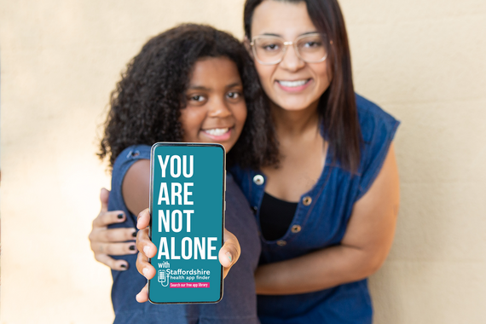
Staffordshire County Council has launched a new campaign to help people find apps they can trust to support mental health.
As you know, young people today face increasing mental health challenges, and finding trusted, effective support can feel overwhelming.
The Staffordshire Health App Finder is a free digital tool, that anyone can use, to find expert-reviewed mental health apps. A new section specifically about children and young people is now live. YP mental health - Staffordshire
The tool is also a valuable resource for those who support young people, including schools, colleges, youth workers, health professionals, parents, and community organisations. It makes it easy for both young people and their support networks to find safe, reliable mental health and wellbeing apps in one place.
Explore the apps

Support the campaign
Downloads resources, including posters and social media posts to promote the campaign.
Check out resources

Request a professional account
If you're a professional you can request a pro account. With a pro account you can create lists of suitable apps, send app recommendations direct to families and young people you're working with, and track which apps have been downloaded.
Find out more about pro accounts - email: lucy.gratton@staffordshire.gov.uk

How to refer a child or young person for mental health and emotional wellbeing support
Support and guidance is provided through the single points of access for north and south, they triage information provided to understand the needs of the child, young person, and their families. Simplifying the way children, young people, their families or carers seek care, support and guidance, also how professionals and others can make a referral.

North Staffordshire:
- Child and adolescent mental health services are accessed via the Single Point of Access (SPA), bringing together children and young people’s mental health services including Stay Well
- Telephone: 0800 0 328 728
- Online referral: Online referral SPA

South Staffordshire:
- Child and adolescent mental health services are accessed via the Children and Families Single Point of Access (CaFSPA), bringing together children and young people’s mental health services including school nursing and Stay Well.
- Telephone: 0808 178 0611
- Email referrals to: CaFSPA@mpft.nhs.uk
- Website: How to make a referral

New toolkit will help schools support children with sensory processing needs
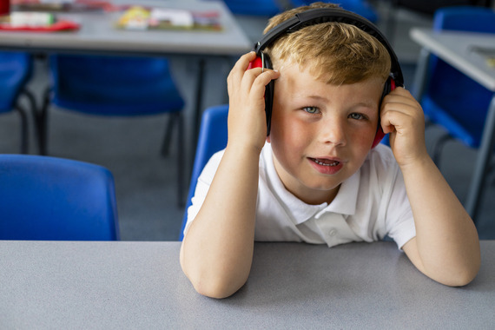
The Sensory Processing Needs Toolkit is a new resource for schools in Staffordshire and Stoke on Trent.
It provides a step-by-step guide on how to support children with sensory processing challenges in the classroom. It offers strategies for teachers to try, advice on assessing the school environment, and ideas for calming activities, helping children take part in school activities.
The toolkit is meant for all students, including those with autism or social/emotional challenges. It focuses on sensory processing needs in general, not on specific conditions. It is not a tool for diagnosing or assessing individual needs.
It provides a step-by-step guide on how to support children with sensory processing challenges in the classroom. It offers strategies for teachers to try, advice on assessing the school environment, and ideas for calming activities, helping children take part in school activities.
Developed by Staffordshire and Stoke-on-Trent Integrated Care Board, Staffordshire County Council, Stoke-on-Trent City Council, Midlands Partnership University Foundation NHS Trust, and North Staffordshire Combined Healthcare Trust.
If you have questions or need more information email: ssotics.comms@staffsstoke.icb.nhs.uk.
Click the button below to download and start using the toolkit straight away.
Toolkit

Staffordshire children's rights service
Advocacy can support the mental and emotional wellbeing of children and young people, encouraging them to make best use of services to support them. Change Grow Live explains the roles of advocates and independent visitors.

What does an independent advocate do?
- Listen to the views, wishes and feelings that a young person chooses to share. With their consent these views can be shared in their own words to ensure their voice is heard
- Inform the young person of their rights and entitlements
- Support the young person at meetings, or they can attend the meeting on behalf of the young person
- Help the young person understand information that has been shared to them by other professionals
- Make the young person aware of the complaints process and support the young person to submit a complaint if this is something they request help with
Who can have an advocate?
- Young people from Staffordshire aged 5-18 who are either a Looked After Child or have a Child Protection plan or have a Child in Need plan
- Young people from Staffordshire aged 5-25 who have Special Educational Needs and Disabilities (SEND)
- Care Leavers from Staffordshire up to the age of 25
Anyone can make a referral, email: sscrs@cgl.org.uk or call: 0747 154 3607.

Download the referral form

What is an independent visitor?

Independent Visitors are adults who offer support to children and young people who are living with a foster family or in residential care. Looking at what the child, young person enjoys doing they are matched with the right person they will get along with. Activities with an independent visitor take place once a month and could include swimming, bowling, football, dog walking, a day out to try something new, visit the local park or anything they enjoy doing.
Who can have an independent visitor?
- Children and young people who are aged 8 to 17 who live with a foster family, in a residential home or by themselves
- With the child or young person's permission, their social worker or carer can refer them
For more information click the button below or call: 07912 120 158 email: SSYPP@cgl.org.uk
Find out more

Resources
Young Minds have a range of information, advice as well as resources including things like wellbeing activities, toolkits and webinars to help you support young people. Mental Health Resources For Children and Young People | YoungMinds
Education support has resources to support school staff with their wellbeing Mental health & wellbeing resources for teachers, education staff & schools. Discover articles, videos and guides to help staff and their organisation with mental health and wellbeing.
Ofqual have Resources for managing test-related anxiety the page has links to organisations with advice for children and young people, parents, and schools. Resources include mindfulness, coping with exam stress as a family, 14 ways to beat exam stress.
The Wellbeing and Recovery College provides recovery-focussed education courses that are free and open to anyone aged 18 or over who live in Staffordshire, Shropshire, Telford & Wrekin and Stoke on Trent. Courses are a mixture of in person or online. Wellbeing & Recovery College

The Wellbeing College offers a range of Free co-produced wellbeing workshops for anyone aged 18 or over in Stoke-on-Trent, Newcastle-under-Lyme, and the Staffordshire Moorlands covering any topic related to wellbeing. Wellbeing College

Dates for your diary


16 May - International boy's day
Internationally boy’s day celebrates the positive elements that boys bring to families and communities and also highlight the issues and challenges boys face.
Celebrating the positive achievements of boys and young men is key to building self-esteem. Self-esteem relates to how much you like yourself, and how you recognise or appreciate your individual character, qualities, skills, and accomplishments.
These resources can help build positive self images:
- Young Minds parents’ guide explains how to recognise low self-esteem, build self esteem along with helplines and websites. Self-Esteem and Mental Health | Guide For Parents | YoungMinds
- PSHE Education Service’s Bitesize Practice Development Webinar with Men @ Work CIC gives practical examples on working with boys and young men.
- Brook offers tips for countering online misogyny in the classroom.
- PSHE education services have resources to address misogyny and toxic influences as well as how to help children and young people to develop empathy and strong values to safeguard them. See link below to sign up.
Let us know if you are planning events or activities to celebrate and we'll share your stories in our next newsletter.

Exam Season
It’s hard to believe that exam season is upon us, and we wanted to provide some resources for those supporting children and young people during this time.
For Young People:
- Young Minds has some Mental Health Advice for Students that includes practical tips on self-care.
- The Sandbox has tips on preparing for exams, study techniques, diet and nutrition to support concentration, focus and energy as people revise.
- Mind has information on exam stress for 11-18 years old, including where to go for help and support.
- Staffordshire health app finder has apps to help relax and feel Young people mental health apps
For Parents/Carers:
- The NHS has information for parents and carers to help their child beat exam stress.
- Young Minds has created a parents’ guide to supporting during exam time and exam stress.
- UCAS has tips for parents and carers on revision and how to manage stress during exam season.

21 June - National selfie day

Comparing themselves to perfect images online can lower the self esteem of children and young people. Let's use this awareness day to build their confidence - we have pulled together some resources that may help:
- Mind offers resources to help young people understand confidence and self-esteem.
- BBC Own It has a lesson for 7-11-year-olds about the effort behind perfect online photos.
- Childnet provides a lesson and film for 11-14-year-olds to explore self-esteem and reflect on the reality of online life.
- Check out apps to help build positive self-esteem and body image on the Staffordshire health app finder Young people mental health apps

July - Talk to us month
Every July, the Samaritans hold events to raise awareness that they are available to listen to anyone struggling, day or night. Find out what Samaritans in Stafford is doing to raise awareness in July.
- Tips if you're feeling lonely
- How Samaritans can help you
Samaritans support schools, colleges, and youth settings through postvention services, lesson plans, and school talks.
Find out more

PSHE Education Services
You can access mental health and emotional wellbeing resources through the Pan-Staffordshire PSHE Education Service’s Central Resource Library. It is free to register an account and there is no limit to the number of accounts an organisation can have. Register for an account.
To sign up for the PSHE digest contact Natalie – natalie@staffscvys.org.uk.

Suicide awareness and prevention
Around ten lives are prematurely lost each month to suicide in Staffordshire. #TalkSuicide is a campaign to bring local individuals, organisations and businesses together to help prevent suicide. You can get free training, resources, downloads, and tools on the #TalkSuicide website.

is an online nudge technique which consists of a powerful message of hope, as well as providing a selection of mental health support resources in a range of different communicative options (call, text, webchat, self-help app, pocket resources). Through R;pple, an individual feeling despair and researching harmful content will be urged to instead seek mental health support they deserve and need in a way that works best for them. Find out more about R;pple.

Prevention of Young Suicide is the UK charity dedicated to the prevention of suicide and the promotion of positive mental health and emotional wellbeing in young people. For confidential suicide prevention advice call: 0800 068 4141 email: pat@papyrus-uk.org text: 88247 or visit their website.

Need urgent help? If you need urgent support, feel unable to cope, are worried about your own mental health or someone you care for, help is available.

Evidence Library
Lost Boys: State of the Nation report from the Centre for Social Justice about young men and boys in the UK. Education, employment prospects, mental health, and the dangers of crime are highlighted as critical areas of concern.
The Good Childhood Report 2024 reveals that too many young people are unhappy with their lives. 11% of the children and young people who completed the survey had low wellbeing. More children and young people said they were worried about rising prices, compared with the other eight societal issues they were asked about. Two in five (41%) children and young people were ‘very’ or ‘quite’ worried about this issue.

Training
Place 2 Be Mental Health Champions - foundation course. A free, online, CPD certified, mental health training course to enhance the understanding of children and young people's mental health in school staff and youth groups.
The course is suitable for people working with children and young people of any age. For more details visit their website: Children’s mental health training course
NSPCC Mental health and wellbeing safeguarding in education training is an online, CPD certified, course to help recognise, respond to and support children and young people's mental health in schools and colleges.
There is a cost involved, for more information: Mental health and wellbeing safeguarding children training
The Open University have free online, CPD certified, Supporting children's mental health and wellbeing course.
Learning outcomes include understand the influences on mental health in young children age 0–5 and develop knowledge about strategies and interventions to improve mental health in children. For more information visit their website: Supporting children's mental health and wellbeing

Mental health helplines and websites
Childnet: Provides online information for parents around supporting children with gaming at different ages. Parents can download their Family Agreement template and find tips on using it with their family.
The Mix: Offers online information as well as helpline support to under-25s about anything that’s troubling them. Email support is available via their online contact form. Free 1-2-1 webchat service and telephone helpline available. Opening times: 4pm - 11pm, seven days a week 0808 808 4994.
Childline: If you’re under 19 you can confidentially call, chat online or email about any problem big or small. Sign up for a free Childline locker (real name or email address not needed) to use their free 1-2-1 counsellor chat and email support service. Can provide a BSL interpreter if you are deaf or hearing-impaired. Hosts online message boards where you can share your experiences, have fun and get support from other young people in similar situations. Opening times: 24/7 Call: 0800 11 11.
Tellmi: Formerly known as MeeToo. A free app for teenagers (11+) providing resources and a fully moderated community where you can share your problems, get support, and help other people too. Download Tellmi: mental health apps for young people
Staffordshire Health App finder has a range of trusted, clinically-reviewed apps to address a variety of mental health needs—whether it’s managing anxiety, building resilience, or coping with everyday stress Staffordshire health app finder.

This newsletter has been produced in partnership with:
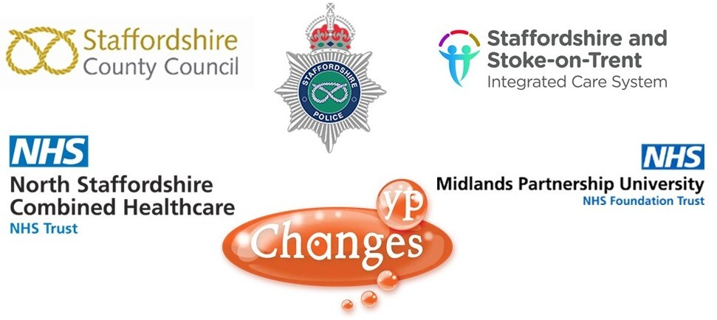

Feedback
We love to hear your feedback. If you have shared websites or resources from Kind Minds with children and young people tell us what have you/they found useful? Please make sure feedback from children and young people is anonymised.
Kind Minds is produced every term, we welcome your thoughts on the types of information that would be most useful to you. Please get in touch with ideas or contributions. sandra.webb@staffordshire.gov.uk

Get future copies of this newsletter
If this email has been forwarded to you, sign up now to have future emails delivered direct to your inbox.
Sign up



