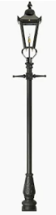
Victorian Day – Year Five / Six
Y6 will be holding a Victorian Day towards the end of the Spring Term.
It would be lovely if children dressed up for the day to enter into the spirit of Victorian times.
Please look for and use clothes you may already have to create clothing for the day:
Victorian Girl Costume (KS2)
What to look for:
- Long skirt (dark or floral)
- Plain blouse or long-sleeved top (white/cream best)
- Cardigan or jumper
- Tights or leggings
- Flat shoes

How to style it:
- Tuck the blouse into the skirt.
- Button cardigan fully.
- Avoid bright colours or logos.
- Pull skirt up slightly higher on the waist if possible.

Easy extras:
- Hair in plaits or a low bun
- Apron (tea towel tied around the waist)
- Shawl or scarf

Victorian Boy Costume (KS2)
What to look for in your wardrobe:
- White or cream shirt (collar if possible)
- Dark trousers (black, brown, grey or navy)
- Waistcoat (or a cardigan worn buttoned up)
- Dark jumper (thin, plain)
- Dark shoes or school shoes
How to style it:
- Tuck the shirt into trousers.
- Button up the waistcoat or cardigan fully.
- Roll sleeves down (Victorians didn’t wear short sleeves).
- Add braces if you have them (optional).
- Part hair neatly to the side.
Easy extras:
- Flat cap or school cap
- Toy pocket watch (or draw one on card)
- Paper newspaper prop

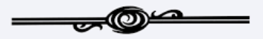

Victorian Factory Child
Items:
- White shirt
- Dark trousers/skirt
- Cardigan or waistcoat
- Boots or school shoes
Extras:
- Paper “lunch tin”
- Name label pinned on
- Smudged face for effect

Poor Victorian Child
(Very Easy)
This is often the most authentic and easiest option.
Items:
- Oversized shirt
- Dark trousers or skirt
- Plain jumper
- Worn shoes
- Cap or messy hair
Styling:
- Roll sleeves unevenly
- Leave shirt untucked
- Smudge a little brown eyeshadow on cheeks (optional)

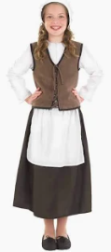
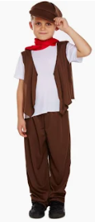
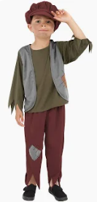
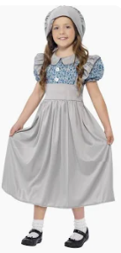
Victorian Day
Friday 13th February 2026

