Reception Class: Remote Learning
Winter Wonderland – Week 3
RWI (Phonics) |  | Complete additional activity sheets linked to sounds being taught within the week.  https://home.oxfordowl.co.uk/reading/reading-schemes-oxford-levels/read-write-inc-phonics-guide/  Please use Geraldine the Giraffe on Youtube:  https://www.youtube.com/results?search_query=geraldine+the+giraffe+  Monday 17th January  Set 1 - f  Set 2 – ar  Tuesday 18th January  Set 1 - e  Set 2 – or  Wednesday 19th January  Set 1 - l  Set 2 - air  Friday 20th January  Set 1 - h  Set 2 - ir  Reading Red words- Can you write a sentence with a red word or one of the new sounds?
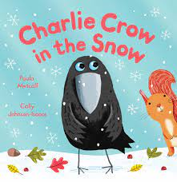
Activity 1: Listen to the story ‘Charlie Crow in the Snow’
Can you re tell the story? Who are the main characters in the story? Why did the crow and the squirrel think something strange was happening? Which character was trying to sleep in his cosy den?
https://www.youtube.com/watch?v=SSAOV7DdGgk

Activity 3: Look at this picture of the seal. What can you say about the picture? Can you describe the seal?What colour is he? What do you notice about his face? How do you think he would feel if you touched him? Try and answer the questions using a sentence. “The seal is grey” “He has got whiskers on his nose.”

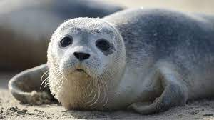

Daily Bedtime Story
Note: Free Reading from Oak National Academy
Story to read that links to our new theme- The Gruffalo’s Child
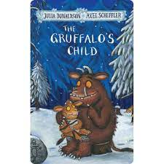

https://www.youtube.com/watch?v=5tM34biTCRg

Writing |  | Activity 1: Look at the sheet in the pack. Can you design your own creature that you might find in the ‘Gruffalo’s Child’ story? When you have drawn your picture, can you talk about what you have drawn? Can you write down some of the words to describe your creature?  See if you can hear any sounds in the words. Make marks on the paper to represent the words you have written.
 |  | Activity 2 : Label the winter clothes (resources provided in pack)
Handwriting | Activity 1- Have a go at the Winter Wonderland pencil control sheets. (Resources in pack)
 | Activity 2- Look at the mark making sheets in the pack. Get a felt pen and see if you can draw over the lines. You could try other tools such as a paintbrush with paint or some chalk. You could sprinkle some flour or sugar/salt on a tray and draw the patterns using your finger.
 | Practise writing ‘b’. Use the handwriting rhyme, “Up we go down to the heel and round the toe”
Maths |  | Activity 3- Understanding the concept of subtraction as take away (Part 1)- Lesson 4  https://classroom.thenational.academy/units/addition-and-subtraction-within-10-d631
 |  | Activity 4- Adding and subtracting using a number track- lesson 5 https://classroom.thenational.academy/units/addition-and-subtraction-within-10-d631
 |  | Activity 5- Counting up to 15 objects and putting them in order (Part 1) https://classroom.thenational.academy/units/numbers-within-15-7d41
https://www.youtube.com/watch?v=0VLxWIHRD4E
Join in with our number songs. We sing these songs every morning during our Maths meeting.

https://www.youtube.com/watch?v=svrkthG2950
 |  | Learning Through Play- Activity 1- ordering numbers work sheet 1-20. Please stick into remote learning book.
 |  | Learning Through Play- Activity 2- complete missing number tracks. Please stick into remote learning book.
Theme |  | 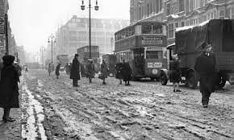  Activity 1 –  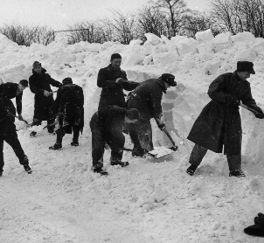  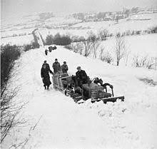  Here are some pictures of the Winter from 1947 which was one of the worst Winters on record. Can you find out any information about this? There is information on the Internet to help you. Find out some facts about how long the snow fell for, how deep was it? How cold was it? What do you notice about the photo’s from 1947? How do we know they are old photo’s?
Physical Development |  | Activity 1 – Complete the cutting sheets (provided in pack)
Activity 2- Have a go at joining in with the Yoga moves in this story about a Winter fox.

https://www.youtube.com/watch?v=XU1y7pX7dNo

Exploring Media. |  | 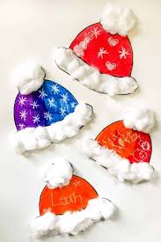  Activity 1 –  Can you design your own Winter woolly hat?  Use cotton wool and bright colours to decorate your hat. Use the template included in pack.
Communication and Language |  | 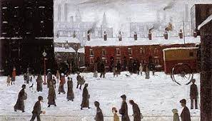  Activity 1-  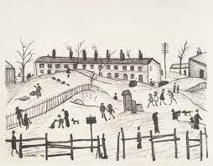  Look at these Winter pictures by the artist L.S Lowry. He used to paint scenes of the town where he lived with small stick men in the picture which were known as ‘Matchstick Men.’  Can you find out anything about the famous artist L. S Lowry? Have a look at the pictures and talk about about what you can see. Do you like the pictures? Do you think they are happy pictures? What do you think of when you see them? Do you think you could draw a “Matchstick Man?”

