Saplings Class: Remote Learning
Exploring Autumn- Week 8
RWI (Phonics) |  | 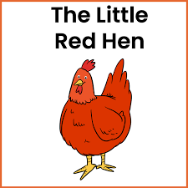  Read the story ‘The Little Red Hen’. Talk about the story with your child. Who are the characters? How do you think the hen felt when nobody would help her? Do you think she felt sad? Angry? What happened at the end of the story? Talk about the story with your child. Which characters do you like?  https://www.youtube.com/watch?v=yclc22I4Zxk  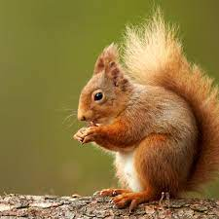  Activity 2: - Look at the picture of the squirrel below. Can you think of words to describe the squirrel? Ask your child what the squirrel’s tail looks like? What do you think he feels like? Encourage your child to answer in a sentence. “The squirrel is soft.” “The squirrel’s tail is bushy.”
Daily Bedtime Story
Note: Free Reading from Oak National Academy
Story to read that links to our new theme ‘Rosie’s Walk’-
https://www.youtube.com/watch?v=1FaRueaFPMk
Writing
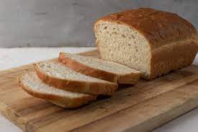
Activity 1 – See resources in pack. Think about the Little Red Hen story. Can you look at the pictures and put them in the right order to make a story map? Help your child to cut out the pictures on the sheet and stick them in the right order.

 |  | Activity 2- Practice writing your name every day!
Handwriting | Activity 1- Complete the handwriting sheets included in pack.
Activity 2-
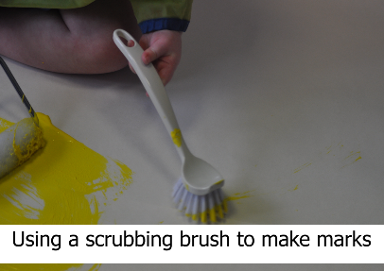
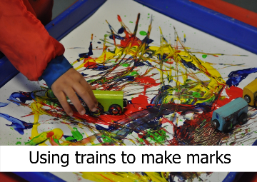
Try these different ways to make marks on paper. Think up some of your own ways to mark make. Can you use different tools to write some letters in your name?
Maths |  | Activity 1- Have a go at the 2D shape picture in the pack. Help your child to cut out the shapes and then stick the shapes onto the sheet to make The Little Red Hen picture. Can you name any of the shapes you are using?
 |  | Activity 2- Complete the Autumn patterns. (Included in pack)
https://www.youtube.com/watch?v=0VLxWIHRD4E
Join in with our number song. We sing this song every morning during our Maths meeting.

Theme |  | Activity 1- Have a go at the What am I Autumn quiz included in pack. Ask the questions to your child and see if they can remember some of the Autumn facts we have talked about.
 |  | Activity 2 – Look at the animal flashcards included in the pack. Can you draw or paint an Autumn animal? Have a look at the animal you want to paint and think about the colours you need to use. How many legs has your animal got? Has it got a pointed face? Has it got a bushy tail?
Physical Development |  | Activity 1 – Cosmic Kids Yoga  Follow the link and join in with the Autumn themed yoga session!  https://www.youtube.com/watch?v=KAT5NiWHFIU&list=PLdonPce-f8Y0SIM-7tOcl5z6YtXpjxe7_  Activity 2 – Follow the link to join in with the Dough Disco session. There is a playdough recipe included in the pack if you do not have any dough at home.  https://www.youtube.com/watch?v=DrBsNhwxzgc
Exploring Media and Materials |  | Activity 1 – Have a go at the Autumn leaf crown. See resources in pack.
Activity 2 –

Can you make your own bird feeders? Look at the pictures here, and see if you can make one to hang in your garden.
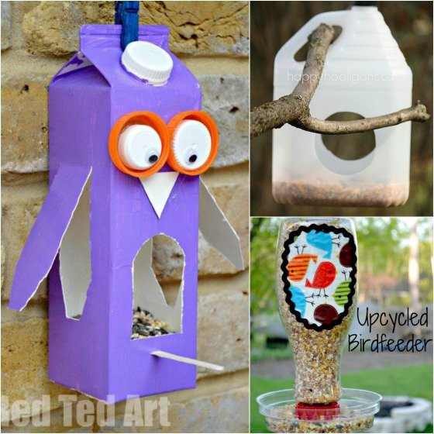
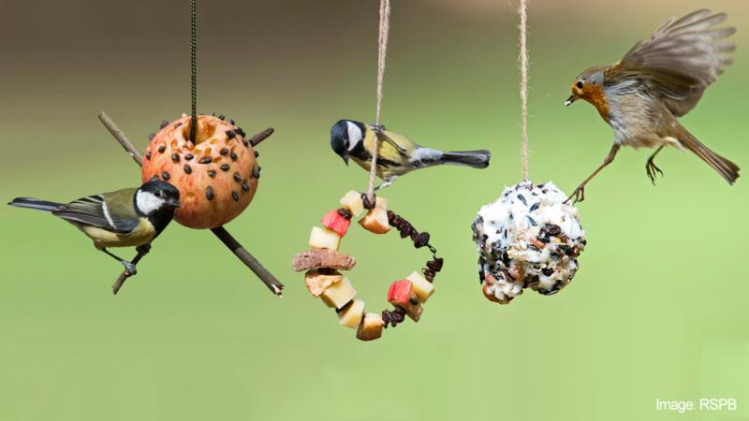

Communication and Language |  | Activity 1- Have a go at the hedgehog biscuits recipe included in pack. Talk about the recipe with your child. What are the ingredients? What do we have to do first? What do you think they will taste like? Write down any observations your child might make.
 |  | Activity 2- We have been talking about different emotions in our ‘Jigsaw’ sessions. We have introduced the children to our Mood Monsters, where children tell us every day how they are feeling. In the pack there is a Mood Monsters board game for you to play with your child. This is a good opportunity to discuss emotions and at what times children have experienced different feelings.
Please send back to school the pieces of work highlighted in blue.
Please do this by 3pm on Friday 22nd Oct 2021.

