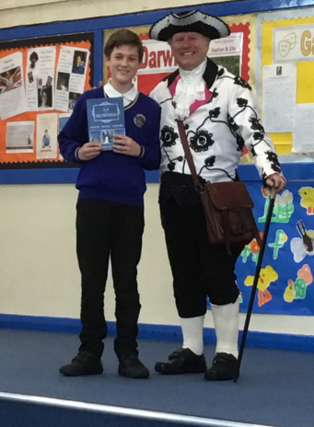
Newsletter Friday 28th June 2019 Issue 35
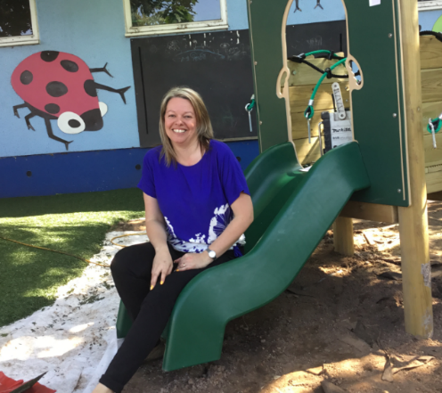

Message from Headteacher

Last week we were visited by OFSTED. The report takes approximately 19 days to be published, which will take us to the last few days of this academic year. However, I would like to take this opportunity to say a HUGE thank you for all the kind messages of support and the overwhelming positive comments that were shared with both staff and OFSTED themselves. I appreciate the turbulent times the school has been through, but last week we all felt a sense of community.

Also last week we held ‘Houses Week’. We had local historian visitors each day to tell us about the people behind the houses we have chosen. Each day the children enjoyed activities related to a specific house. This week was extremely valuable, and added a real sense of community to our learning. Children and staff are far more knowledgeable about our local history.

Last night was the summer disco. Everyone had a wonderful time. We raised just over £500 which we are going to use to buy a woodwork station for Early Years, to enhance their new outdoor learning area.

As you are aware, we have worked incredibly hard updating our website this year. It is now our biggest resource with the most up to date information. During the year we have also launched a Twitter page and revived the Facebook page. All these aim to improve communication. In recognition of our efforts to engage parents and get the most from the internet platform, we have been awarded a silver ‘Orderly Oracle’ and a gold ‘Content Commander’. Well done Mrs Mace, who looks after this very valuable part of our school.

What’s on next week

Monday 1st July:

- Years 5 & 6 Swimming Gala
- KS2 Badminton 3.20-4.20pm
- Lego Club 3.20-4.20pm

Tuesday 2nd July:

- Choir 8.20-8.50am
- Transition Morning in School
- Singing, Woodwind & Guitar Lessons
- KS2 Athletics 3.20-4.20pm
- Reception to Year 1 Transition Meeting 6pm

Wednesday 3rd July:

- EYFS Trip to Tamworth Castle
- Violin & Keyboard Lessons

Thursday 4th July:

- Drum Lessons
- KS1 Athletics 3.20-4.20pm
- Year 2 to Year 3 Transition Meeting 6pm

Friday 5th July:

- Year 5 Workshop at Nether Stowe School
- KS2 Rounders 3.20-4.20pm
- Reports sent home

Years 1 & 2
This week we have been doing lots of work around elections for our School Council. We decided on characteristics that a good school councillor would need and then thought about whether we wanted to put ourselves forward. Candidates then gave speeches to the rest of the year group who voted at our polling station. We look forward to revealing who won the election!
In PE we have been getting our skipping ropes out to practise our skills! Some of the children are making fantastic progress with this already.
Please can we have any socks to use for our sock puppets, thank you!

Years 3 & 4
We thanked the children for their excellent behaviour last week when we were visited by Ofsted.
Their manners, attitude to learning and general behaviour was great. This is by no means unusual, as we are often proud of children's behaviour but it is always nice to be noticed by visitors!
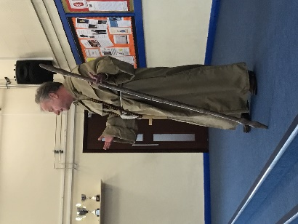
We had a lovely week when we celebrated our 'Houses' and especially so when we visited two of our historical attractions - Erasmus Darwin House and Dr Johnson's Birthplace.
Also the children have been really enjoying Greek myths and legends and were especially 'gripped' when they had to listen to the story of Theseus and the Minotaur and convert it into a play script.
We have been getting started on our end of year assessments this week and the children deserve credit for their hard work again!

Years 5 & 6
We have had yet another exciting and busy week. On Tuesday we were fortunate enough to see the High School Musical dress rehearsal wonderfully performed by pupils of the Friary School (many of which were ex pupils); on Thursday most of our pupils were involved in a puberty session with the school nurse, who made specific comment on the maturity and behaviour of our children and on Friday we were really pleased that so many of our pupils volunteered to help out at the Summer Fayre, again their behaviour was excellent, their reliability and how they handle responsibility is commendable.
We look forward to the many enjoyable activities we have planned for the coming weeks.

Houses Week
All children throughout school had a wonderful time learning about their houses last week, each day started with an exciting assembly about their house.
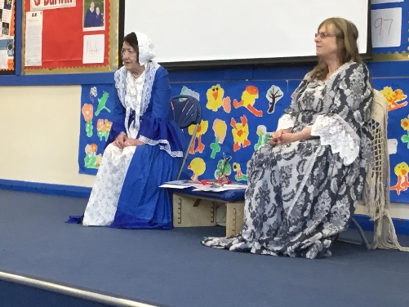

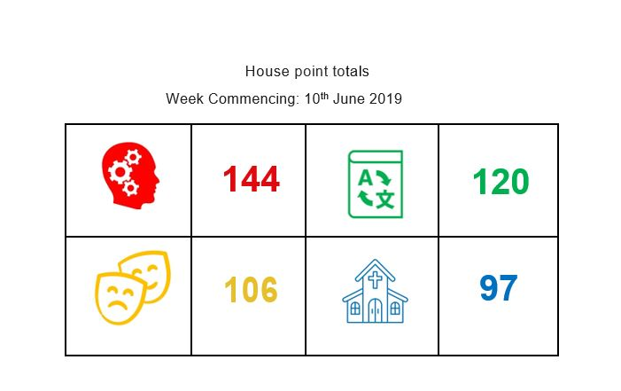

Transition Day

Your children will meet their new class teacher on the morning of Tuesday 2nd July. This is an ideal opportunity to see their new classroom and to prepare for the next year. It is a very exciting time. You will also receive confirmation of your child’s new class in the end of year school report which is sent out on Friday 5th July – should your child forget to tell you!

Class arrangements for next year remain the same:
Early Years: | Miss Morton  Mrs Pearson  Mrs Rigby | Willow & Acorn
Year 1 & 2 Mixed | Miss Tullett | Apple
 | Mrs Bishop | Beech
 | Miss Hathaway | Elm
Year 3 & 4 Mixed | Mr Budge | Sycamore
 | Miss Robinson | Ash
 | Mrs Taylor (Mon – Wed)  Mrs Parrish (Wed – Fri) | Birch
Year 5 & 6 Mixed | Mr Stevens | Elder
 | Mrs Miles (Tues – Fri) | Oak
 | Mrs Chapman | Rowan
 | Mrs Cadman will support learning during the mornings in Years 5 & 6.

Whilst considering arrangements for next year there are two brief meetings next week regarding transition:

Current Year Reception children – Tuesday 2nd July 2019 KS1 Hall 6pm

The change from the Early Years Curriculum to the National Curriculum is the biggest change for primary aged children. The learning style becomes more formal, and although the children adapt very quickly and much transition work is done in school, often parents can feel apprehensive.

This meeting is to explain the differences and an opportunity to ask any questions. This meeting will include a tour of the Infant building.

Current Year 2 Children – Thursday 4 July 2019
KS2 Hall 6pm

The change for infant children is not as big, as they already follow the standards expected of the National Curriculum. But as they progress into the Juniors there are some practical changes to be made aware of. As the children become older they develop more independence and this is encouraged as they move into this stage of their education. This meeting will include a tour of the Junior building.

Message from the Local Governing Body

The Governing Body is looking for a Parent Governor to join them from September 2019. Would you like to join us? Governance is a fulfilling way of getting involved in the future of YOUR school by building a positive relationship with staff and pupils to work as a TEAM for the benefit of all the children.
As a Governor, you would attend meetings to discuss the children’s progress and school priorities and make visits to school on a specific subject area to support with challenges and celebrate improvements.
You don’t have to know anything to start with, as training is given and you will be welcomed and supported as you grow into the role.
As part of the Community Academies Trust, there are opportunities to meet people from other Trust School’s Governing Bodies, attend the Trust’s Annual Governor’s Conference and take advantage of the training and development opportunities.
Please call into the office for more information if you are interested.

