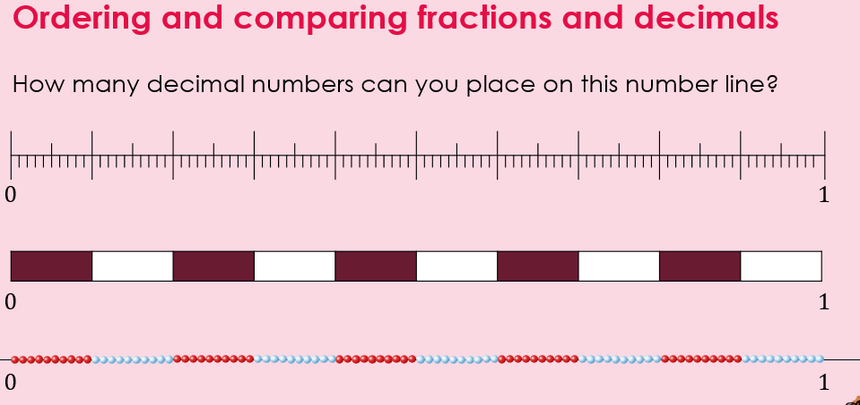

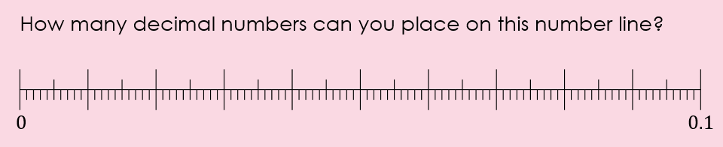

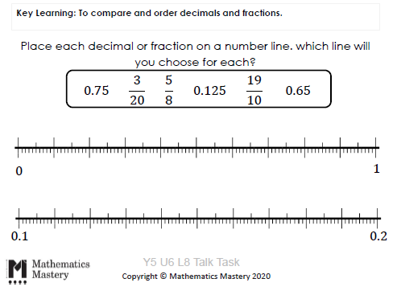

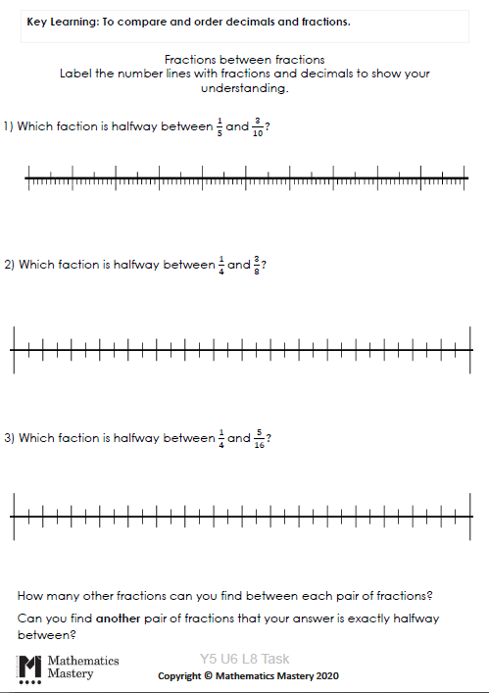

Show where the fifths would be on the number line
Show where the tenths would be on the number line.
Find half way
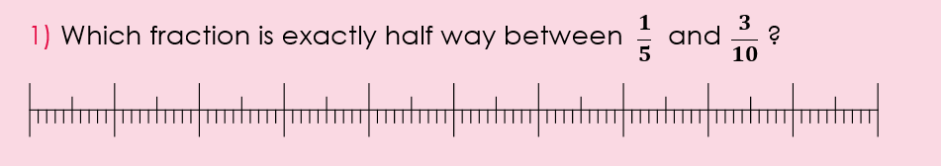

Show where the quarters would be on the number line
Show where the eighths would be on the number line.
Find half way

