Saplings Class: Remote Learning
Winter Wonderland – Week 4
RWI (Phonics) |  | Activity 1: Listen to the story ’One Snowy Night.’  Who are the main characters in the story? Why do the animals knock on Percy’s door? Can you remember some of the animals that visited Percy? Which animal was underneath the floorboard in Percy’s house?  https://www.youtube.com/watch?v=K-8AAisU1w0  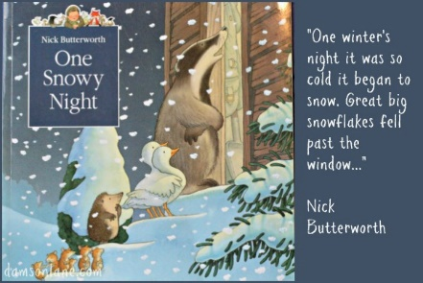  2: Think about the letter ‘a’..Can you think of some words that begin with that sound? Can you have a go at writing the sound? Have a go at the letter ‘a’ cut and stick activity included in the pack.  3. Look at the picture of the children on the sledge. Can you describe them? Can you talk about the picture? What do you think the children have been doing? What season do you think it is in the picture? Have you got a sledge? What does it feel like when you are on it? If you haven’t got a sledge, can you imagine how it would feel zooming down a snowy hill?  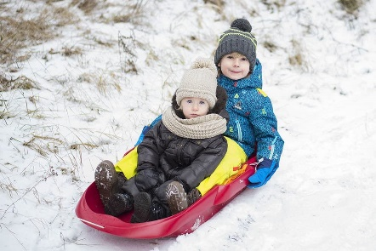
Daily Bedtime Story
Note: Free Reading from Oak National Academy
Story to read that links to our new theme- The Gruffalo’s Child
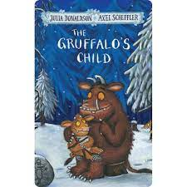

https://www.youtube.com/watch?v=5tM34biTCRg

Writing |  | Activity 1: Can you write a list of Winter clothes that you might need if you went out sledging? What clothes are the children wearing on the photo? Remember when you write a list, your words have to be underneath each other. See of you can hear sounds in the words that you are writing. Write down the sounds you hear or make marks on the paper to represent your words.  There is a sound mat below to help you write the letters.  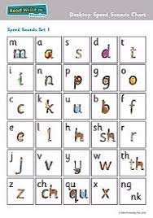
 |  | Activity 2 : Practise writing your name every day!
Handwriting | Activity 1- Look at the sheets in the pack. Can you colour in the letter ‘a’ and practice writing the letter sound? Can you colour in the objects beginning with the letter ‘a’?
 | Activity 2- Look at the mark making sheets in the pack. Get a felt pen and see if you can draw over the lines. You could try other tools such as a paintbrush with paint or some chalk. You could sprinkle some flour or sugar/salt on a tray and draw the patterns using your finger.
Maths |  | Activity 1: Can you match the numeral to the correct quantity on the Winter picture cards. (See resources in pack.)
 |  | Activity 2: Have a go at the colour by numbers colouring sheets (included in pack)
https://www.youtube.com/watch?v=0VLxWIHRD4E
Join in with our number songs. We sing these songs every morning during our Maths meeting.

https://www.youtube.com/watch?v=svrkthG2950

Theme |  | 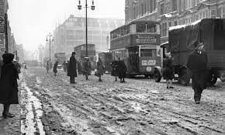  Activity 1 –  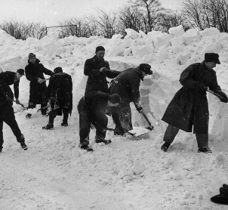  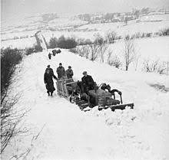  Here are some pictures of the Winter from 1947 which was one of the worst Winters on record. Can you find out any information about this? There is information on the Internet to help you. Find out some facts about how long the snow fell for, how deep was it? How cold was it? What do you notice about the photo’s from 1947? How do we know they are old photo’s?
Physical Development |  | Activity 1 – Complete the cutting sheets (provided in pack)  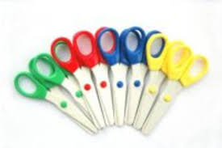
Activity 2- Have a go at joining in with the Yoga moves in this story about a Winter fox.

https://www.youtube.com/watch?v=XU1y7pX7dNo

Exploring Media. |  | Activity 1- Have a look at the instructions in the pack. Can you have a go at making your own paper snowflakes?  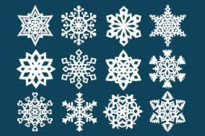
Activity 2 – Follow the instructions in the pack to make a paper plate igloo.
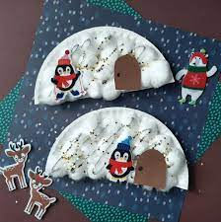

Communication and Language |  | 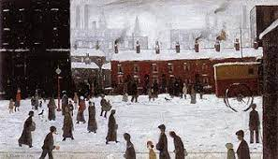  Activity 1-  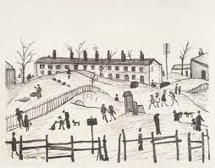  Look at these Winter pictures by the artist L.S Lowry. He used to paint scenes of the town where he lived with small stick men in the picture which were known as ‘Matchstick Men.’  Can you find out anything about the famous artist L. S Lowry? Have a look at the pictures and talk about about what you can see. Do you like the pictures? Do you think they are happy pictures? What do you think of when you see them? Do you think you could draw a “Matchstick Man?”

