Saplings Class: Remote Learning
Me and My Community- Week 7
RWI (Phonics) |  | Read the story ‘Little Red Riding Hood’. Talk about the story with your child. Who are the characters? Should Little Red Riding Hood have talked to The Big Bad wolf? Why was she going to visit her grandmother? What do you think was in her basket?  https://www.youtube.com/watch?v=0W86K1jBJFI  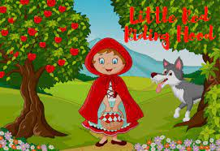
Daily Bedtime Story
Note: Free Reading from Oak National Academy
Story to read that links to our new theme ‘Rosie’s Walk’-
https://www.youtube.com/watch?v=1FaRueaFPMk
Writing
Activity 1 – Go on a walk with your child. Talk about the direction you are going in. Explain left and right and point out landmarks on your journey. It might just be a walk around the garden or a trip to the shops.
See if you and your child can draw a map of your journey, draw pictures or take photo’s of the things you saw. Label your map. Write down what the children say. See if they can give meaning to their marks. They may be able to hear some initial sounds such as M for Morrisons. Write the letter and see if they can copy it.
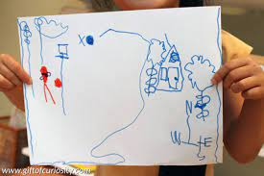

 |  | Activity 2- Practice writing your name every day!
Handwriting | Activity 1- Complete the handwriting sheets included in pack.
Activity 2- Have a go at attaching different
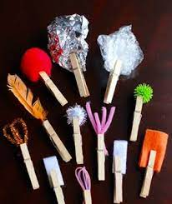
materials to some clothes pegs. Dip them in
paint and see what different marks you can
make. See if you can create zig zags, squiggly
lines or even the letter that is at the star of
your name!

Maths |  | Activity 1- Have a go at the Autumn Number Matching Activity included in pack.
 |  | Activity 2- Cut out the pictures and numbers. See if you can work with your child to stick the correct number next to the right picture.
Theme |  | Activity 1- Read about hibernating animals with your child and then complete the hibernation sorting activity.
 |  | Activity 2- Try some new fruits and vegetables. What do they look like? What do they smell like? How do they taste? Do you have to cook them before you eat them? Do they grow in the ground or on trees?
Physical Development |  | Activity 1 – Cosmic Kids Yoga  Follow the link and join in with the Autumn themed yoga session!  https://www.youtube.com/watch?v=KAT5NiWHFIU&list=PLdonPce-f8Y0SIM-7tOcl5z6YtXpjxe7_  Activity 2 – Follow the link to join in with the Dough Disco session. There is a playdough recipe included in the pack if you do not have any dough at home.  https://www.youtube.com/watch?v=DrBsNhwxzgc
Exploring Media and Materials |  | Activity 1 –? Look at the instructions provided in the pack. Can you make a leaf man using leaves that you find outside?
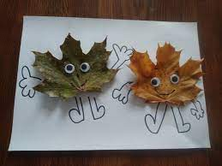
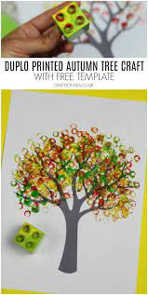
Activity 2-
Have a go at some of these Autumn activities.

Communication and Language |  | Activity 1- Questions to talk about…  Talk about using gentle hands. We all make mistakes sometimes but can we say sorry and find a better way to play? What can we say or do when we feel ourselves getting angry? What if someone is hurting or annoying you?
 |  | Activity 2- In RE, we have been talking about what makes a special friend. Ask your child about their friends. What do they like about them? How are they a good friend? Can your child draw a picture of their friend or friends and talk about them? Use the resources in the pack to draw your friends.
Please send back to school the pieces of work highlighted in blue.
Please do this by 3pm on Friday 15th Oct 2021.

